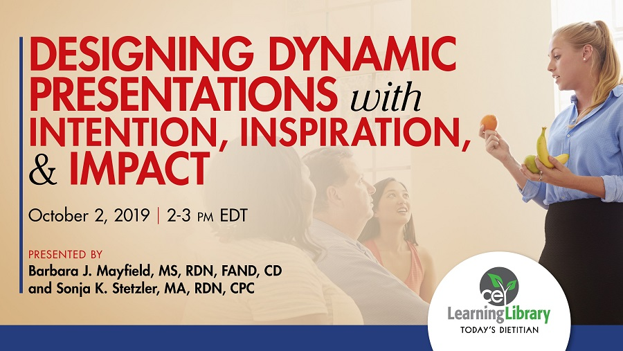

Participant Workbook
Nutrition professionals work in a variety of positions where they need to deliver presentations to inform, influence, and inspire targeted audiences. For example, a dietitian may need to educate consumers on food choices, present to other healthcare professionals on a condition that requires Medical Nutrition Therapy for a successful outcome, or present an innovative idea to senior leadership within their organization. Dietetic curricula at the undergraduate, graduate, and supervised practice levels rarely contain dedicated nutrition communication courses that teach presentation skills or provide the depth necessary for highly successful outcomes that address a variety of audiences. To help fill the gap in nutrition professionals' education, this webinar will discuss how to design a presentation that confidently and competently addresses audiences, and achieves personal and audience-centered outcomes.

Learning Objectives:
By attending this webinar, participants will be able to:

- Identify the purpose for presenting as well as identify measurable outcomes the audience will achieve as a result of attending their presentation.
- Analyze target audiences in terms of the audience’s wants, needs, knowledge, beliefs, and more, and account for these audience characteristics when designing a presentation.
- Craft a core statement that lays the foundation for a presentation and upon which the entire presentation is built – including key messages, supporting evidence and examples, and application activities.

Suggested CDR Learning Needs Codes: 1090, 1130, 6050, 7120
Performance Indicators: 2.1.6, 2.3.3, 9.4.7, 11.4.1
Level: 2

What is a Dynamic Presentation?

In today’s webinar you will learn the rationale and strategies for:
- Beginning your presentation design by identifying your purpose.

- Conducting an audience assessment, which can be the key to a dynamic presentation, and you will commit to never neglecting this step.
- Crafting a core message, which lays the foundation upon which your entire presentation is built.
- Writing measurable and meaningful outcomes, which will provide direction and demonstrate success.
- Creating an organizing framework and selecting the content that will deliver the impact you desire.
- Increasing audience engagement.

Design Dynamic Presentations with intention, with purpose. Answer “why?” Think about the reasons for the presentations you give. List one or more below:

Examples of audience-centered purposes:
- To gain knowledge to solve a problem, prevent a negative outcome, or achieve a positive outcome.
- To gain awareness of an issue.
- To shift an attitude from negative to positive.
- To build a skill needed to perform a job- related task.
- To learn strategies for making behavior changes in order to reach a particular goal

Examples of speaker-centered purposes:

- To fulfill a job responsibility to teach or train a specific audience.
- To share expertise with a target audience that could result in more clients
- Sell/promote an idea, service, or product
- Build credibility and visibility as an expert that would result in more business/clients/income

In general, audience-centered purposes are to inform, inspire, or influence:

Informing = elevating the knowledge of your audience – teaching something they need and want to know Inspiring = elevating their attitudes – shifting their thoughts and feelings about a topic or an issue; and Influencing = motivating behavior change – looking for them to take some type of action.

Ask: “What do I want my audience to know, feel, and do as a result of my presentation?”
Putting it into Practice:
Consider an upcoming presentation you need to design, or one you would like to propose to present to a group.
Who is the audience/location/event/etc.?

What is your primary audience-centered purpose? What are secondary audience-centered purposes?
What are your speaker-centered purposes?

How should you determine what content to include in a presentation and how to present it?

Benefits of conducting a needs assessment:
- Prevents missing the mark and wasting resources covering topics they don’t need or want. Prevents “one-size-fits-all” communication.
- Based on adult learning theory, knowing what an audience knows about your topic enables you to “anchor” new information on what they already know.
A needs assessment determines gaps between what an audience knows/thinks/does and what they need to know/think/do. Helps determine appropriate breadth and depth of topic coverage.
- Involves audience and demonstrates interest in them, builds trust and mutual respect, and leads to audience support of communication which results in audience buy-in and ownership.
- Creates a meaningful connection between the speaker and audience promoting further exchange and interaction. Helps select in choosing examples that are relevant and meaningful to the audience.
- Informs the speaker of the audience’s preferred style of communication and the types of activities to include.
Needs Assessments – Stories from Experience:
Team Nutrition Child Care Culinary Workshop
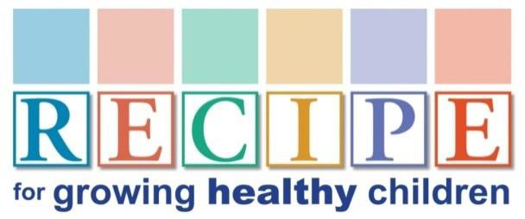
R = Role model
E = Environment
C = Create delicious and nutritious meals and snacks
I = Involve children in food and fun
P = Partner with parents
E = Enjoy eating together
Ask the audience what they want to learn about.
Determine if assumptions about knowledge, attitudes or behaviors are accurate.

Nutrition Communication Course – Community presentation to young gymnasts
Ask the audience what they want to learn about!

Sports Beverage Company – 4 different audiences require 4 different approaches
Evaluate the audience to determine values and motivations.

Learn where your audience stands
An additional benefit of an audience assessment is knowing where your audience stands, especially regarding potentially controversial topics.
- Provide audience members who agree new information, reinforce why they agree.
- Provide audience members who are indecisive or apathetic with new information and focus on what’s in it for them.
- When audience members disagree, find common ground, acknowledge their opinions and demonstrate respect for their viewpoint. Use fair and well-researched evidence and build credibility through expertise and trustworthiness.

Are you committed to conducting a needs assessment when designing a presentation?
€ YES € NO € MAYBE

How to conduct a needs assessment:
- Identify audience to assess.
If the audience is small and conveniently accessible, assess the entire group. If the audience is larger, target a smaller representative group. Determine the need to conduct probability sampling with random selection, or if non-probability sampling is acceptable. If non-probability sampling is used, such as using a convenience sample, recognize the potential for bias in the sample. Informal feedback from colleagues or members of the target population can also provide useful information. Examples of this include comments gathered from social media.

Determine information to collect.
Prioritize what is needed to fulfill the purpose of the presentation. This can include any or all of the following: audience knowledge, attitudes, values, and beliefs, behaviors and practices, motivators, barriers, and readiness to change, demographics, learning style preferences, channel preferences.

Use secondary, or existing, data first.
Before collecting primary data directly from the audience, seek sources of secondary data that will inform you of problems and needs in your target audience.

Determine approaches to collect primary data.
These include surveys, (for instance using surveymonkey.com) to capture information from the group. You can interview select members of you audience, you can hold focus groups, and observations. A newer approach to collecting information from an audience is Photovoice, which is a process that allows people to use videos and photos to describe their situation and their needs.

Needs assessment resources:
Tool kit for conducting community assessments: http://ctb.ku.edu/en/assessing-community-needs-and-resources

Community-Based Participatory Research:
http://ctb.ku.edu/en/table-of-contents/evaluate/evaluation/intervention-research/main

How to conduct a cognitive interview: A nutrition education example guide: www.au.af.mil/au/awc/awcgate/usda/cog_interview.pdf

Designing and conducting focus group interviews guide: www.eiu.edu/ihec/Krueger-FocusGroupInterviews.pdf

Tips for effectively using Photovoice, provided by the Community Tool Box: http://ctb.ku.edu/en/table-of-contents/assessment/assessing-community-needs-and- resources/photovoice/main

Putting it into Practice:
Begin planning your needs assessment by answering the following questions:

What audience (entire group, representative group, similar group) will I assess?

What information will I collect?

What secondary data sources can I research?

What methods will I employ to collect primary data?

What is your “Big Idea” (core message, premise statement…)?

“A statement of conviction that takes a position on whatever your topic may be.”
Michael Port, Steal the Show
- 1 sentence summary of your presentation
- Message you want your audience to remember
- 10-15 words in length
- Forms the foundation upon which you build your presentation.

Putting it into Practice:
Use this space to brainstorm ideas for a core message:

The Purpose of Learning Objectives:
- The knowledge, emotions, or skills participants will know, feel, or be able to demonstrate
- Identify what you want to accomplish
- Decide what to focus on
- Tell your audience what they will gain
- Define what the audience will learn and how they will be able to use the knowledge
- Provide a tool for measuring outcomes

Learning objectives are measurable and descriptive with 3 key components:
  - An active verb
  - A subject, typically a noun
  - Specific criteria that allows evaluation of success

Links to Bloom’s Taxonomy of Educational Objectives:

Three domains of learning: Cognitive, affective, and psychomotor: https://thesecondprinciple.com/instructional-design/threedomainsoflearning/

Bloom’s revised taxonomy: Cognitive, affective, and psychomotor: www.astate.edu/dotAsset/7a3b152c-b73a-45d6-b8a3-7ecf7f786f6a.pdf

Iowa State Center for Excellence in Teaching and Learning—Revised Bloom’s taxonomy: www.celt.iastate.edu/teaching/effective-teaching-practices/revised-blooms-taxonomy

Creating a learning objective:

 | Domain | Class | Verb(s) | Subject/ Noun | Evaluate/ Measure
Example objective:  The participants will be able to demonstrate proper handwashing techniques while explaining the 5 steps. | Cognitive | Understanding | Demon- strate and Explain | Handwashing | 5 steps: 1.wet 2.lather 3.scrub 4.rinse 5.dry
Objective:
Determine: How will you assess your audience learning objectives? How could you assess your speaker-centered objectives?
(questions on the evaluation, track referrals, clients enrolled, sales made…)

Putting it into Practice:
Write 3 learning objectives for your presentation: 1.

2.

3.

Key Points:
- Write 3-5 key points that directly relate to your core message/big idea. Each point will emphasize each objective or outcome you have chosen.
- Write with clarity! If you choose to be clever, be sure you are also clear. “If you confuse, you lose!” Donald Miller, StoryBrand Founder
- Write with positive framing rather than negative (pilot test to find out whether audience assessment indicates otherwise)
Putting it into Practice:
Write 3 key points for your presentation: 1.

2.

3.

Build Your Content on a Unifying Theme
- Curriculum-based
- Message-based
- Time-based
- Sequential
- Spatial
- Problem/solution
- Cause and effect
- Compare and contrast
- Topical
Putting it into Practice:
Describe the unifying theme you will use to structure your presentation:

Brainstorm content to cover:

- Support your key points
- Use adequate evidence and examples
- Make it meaningful to the audience
- Make it essential – only address what the audience needs

Organize supporting evidence using the acronym NEST:

- Narratives
- Examples
- Statistics
- Testimony

Plan opportunities for interaction
Interaction and engagement enhance the learning experience and improve the outcomes:
Ask questions: A good opening question can connect the audience to the topic and provide you with immediate feedback. Polls and surveys can provide you with your audience’s opinions.
Quizzes show you and your audience what they know (or don’t know) and can be a fun way to present information through the answers. Reflection questions help audience members think about their learning.
Pair up: Partner activities are a great way to engage the entire audience. Most people hesitate to speak up in front of a group, but are comfortable talking with the person next to them. A classic activity is “Think-Pair-Share,” which asks participants to think about a topic, pair up to discuss, then invites volunteers to share. Pairing up engages everyone.
Engage Everyone: Throughout a presentation, implement a variety of approaches that engage everyone. These can include everything from individual activities participants complete to apply the content, to large and small group activities that get people up and moving, interacting around tables, or playing a game to assess knowledge gains. Turn your audience into active, engaged participants.

4 techniques to keep an audience engaged:
(Sharon Bowman, authority on learning)

Novelty - anything in the environment that is new to the audience’s experience (could be a change in props, slides, movement, etc...)
Contrast - something in the environment that is in contrast to other things (change in your voice from loud to soft or fast to slow)
Meaning - this is something in your presentation that holds meaning for audience members (this is why knowing your audience and anchors are so important)
Emotion - anything that make someone respond emotionally, such as a story or humor

Use Emotionally Competent Stimuli (ECS)
Brian Medina, Brain Rules, recommends ECS to gain attention by triggering emotion in a manner relevant to the audience. Stories are effective for this purpose; they promote release of oxytocin and produce a feeling of trust.

Partner Activities

Think-Pair-Share
Give the audience 30 seconds to answer a question or write down at least one idea in their notes (think).Then ask them to discuss what they wrote with the person sitting next to them (pair). Finally, ask for volunteers to share their answers or ideas with the entire group (share).
Pair-Share-Repeat
After a think-pair-share activity, ask participants to find new partners to share what the original partners discussed.
Wisdom of Another
Adapt Think-Pair-Share to require participants to share their partner’s ideas with the entire group.
300 Year Gap Conversation
Break participants into pairs and designate one as A and the other as B. “A”’s portray a modern day person with the task of explaining the use and value of a modern day object or idea to B, who portrays someone from 300 years ago. B can ask questions to help them understand. This activity works well for discussions of technological advances – how we treat disease, how we
prepare food, ways we communicate.
Partner Interviews
One person is designated as the interviewer and the other the interviewee. Provide potential questions that relate to your presentation topic. After a few minutes, partners switch roles. This activity encourages participants to discuss what they found interesting and what they intend to try as a result of learning.
Source: Communicating Nutrition, Chapter 20, Engage Audiences with Participation Strategies

Group Activities

Ice breakers
Get-acquainted games and activities work well in small groups. Numerous types of ice breaker activities can be found in books and online.
Brainstorming
A useful technique for generating ideas or solutions to problems. Ideally, brainstorming occurs in small groups, even if ideas are later shared in a larger group.
Role playing
For role playing scenarios that involve more than two players, form small groups. Allow extra members to serve as a director, an observer that comments on what is done well or could use improvement, and a group member to video record the action and play it back for a group
discussion.
Team games
Team games such as Jeopardy can be used to assess learning. Other examples are relay races to perform a skill or complete a sorting activity, and team quizzes.
Debates
Split group in half and assign each team to support one side of an issue.
Panel discussion
In a setting in which small groups have discussed a topic or generated ideas, use a panel
discussion format to present back to the entire group. This allows for questions and whole group interaction about each topic.
Simulations
This large group activity requires significant planning and preparation, but the outcomes are worth the resource and time investment. Examples are poverty simulations which allow participants to experience what it is like to live in poverty; and simulations to experience living with a disability, being elderly, or traveling to another part of the world.
Source: Communicating Nutrition, Chapter 20, Engage Audiences with Participation Strategies

Gallery Walk
This activity simulates walking around an art gallery – participants walk around the room and look at words or pictures displayed on the walls which link to the issue or topic. Activities may be completed at each display. It can involve group members moving to stand next to a word or
picture in response to a question.
Live Barometer
This activity is a type of body voting used to assess audience members’ opinions, practices, or beliefs. It requires a large open space. A facilitator gives two options and audience members move to one side of the room or the other to show their preferences or practices. If neutral is
an option, they can stand in the center.
Source: Communicating Nutrition, Chapter 20, Engage Audiences with Participation Strategies

Audience Reflection Activities

3-2-1 Reflection
Write down 3 facts or ideas you learned in this session.
Write down 2 questions you still have that you’d like to look up and learn about later. Write down 1 opinion you have about what was covered in this session.
Most important
Write down 3 new ideas you learned in this session. Put a star by the most important.
One question
Write one question about what you’ve learned. (These could be collected for Q&A.)
Muddiest Point
Write down what is most confusing about what was just learned. (Can be collected and redistributed among audience members to read out loud and try to answer.)
Wow & How About
Provide all participants with two sticky notes. On one write a “Wow” statement – what you
learned that was most intriguing. On the other write a “How about” question or idea – another question or idea stimulated by the discussion. Post the two groups of notes on two labeled flip charts and debrief as a group.

Personal reflection
Following a group brainstorming activity, ask participants to reflect on which idea they are most inclined to support, do first, etc.
One Word Splash
Write down one word that describes something you learned or experienced in the session. (Participants can submit their word on an index card or slip of paper or upload it using an interactive tool such as Poll Everywhere to create a word cloud.)
One Minute Paper
In one minute, write down what you learned or experienced in this session.
Look Back and Bridge Forward
Ask participants to individually answer a series of questions that involve reflecting on past, current, and future practices. (Can also share answers with a partner or group.)
Goals and action steps
Based on what you learned, what is one goal and one or more specific action steps you intend to achieve in the next (week, month)?
Three applications
Write down 3 ways you can apply what you learned. Circle what you plan to do first.
Source: Communicating Nutrition, Chapter 20, Engage Audiences with Participation Strategies

Putting it into Practice:
Describe strategies you plan to implement to promote engagement and interaction:

Start Strong
- Open with a story
- Tell a little-known quote or statistic
- Start with a provocative question
- Other:

Conclusions
- Tell (or finish) a story
- End with a quote
- Provide a call to action
- Use “bookending” to complete the opening

“Last words linger, let them be yours.”
Patricia Fripp, past president of the National Speakers Association
Putting it into Practice:
Describe how you plan to begin and end your presentation:

Question and Answer Break – don’t go away, more to come ↓↓↓↓↓↓↓↓

Principles for selecting content and delivery approaches:
Anchor new information to old
Use what you learn about your audience to connect new information in meaningful ways to what they already know and understand.

Teach to a variety of learning style preferences1,2
Identify your audience’s preferred ways to learn and incorporate a variety of approaches (using list below).
Audience members have limited capacity for processing and storing information and have limited attention spans. Prioritize content to be presented. Keep at the appropriate level for the audience. Use language and examples audience understands.

Verbal/linguistic spoken & written words: reading, listening, speaking, writing
Logical/mathematical problem-solving, structured learning
Visual/spatial visual aids and images
Bodily/kinesthetic movement and note-taking, concrete experiences Musical/rhythmic use of songs, patterns and rhythms Interpersonal/relational discussions, brainstorming, collaborative learning Intrapersonal/Introspective reflection, independent work
Naturalist science and nature, learning through classification
Imaginative learners process information reflectively and process it by feeling. They strive to connect personally to information. Educational activities they learn best with include trigger films, demonstrations, hook questions, brainstorming, puzzles, observations, and games.

Analytic learners perceive information abstractly and process it reflectively. They learn by thinking through concepts and pay attention to expert opinions. They thrive in traditional lecture settings and enjoy discussions, debates, readings, journals, etc.

Commonsense learners perceive information abstractly and process it actively. They learn by applying theories to practice and are avid problem solvers. They need to know how things work and want to put information that is learned to immediate use. They like making graphs and charts, drawings, doing case studies, writing activities and worksheets.

Dynamic learners perceive information concretely and process it actively. They learn by trial and error and are enthusiastic about new things. They like taking risks and change. They want hands-on activities, action plans, developing products, videos, skits and simulations. They like working out in the field.
- Gardner H. Multiple Intelligences: New Horizons in Theory and Practice. New York, NY: Basic Books; 2006.
- Kolb DA. Experiential Learning: Experiences as a Source of Learning and Development (2nd ed.); Upper Saddle River, NJ: Pearson Education; 2015.

Explain “why” and create context
Lee LeFever, The Art of Explanation, illustrates the difference in knowledge and interest among audience members with a scale of A to Z.

A… Z

zero knowledge expert knowledge
no interest strong interest
Begin content delivery by explaining why the topic is important and creating context before moving up the scale to providing more knowledge or putting it into practice.

Provide practical learning experiences
Help the audience solve problems, apply information in real-life ways, and determine goals and action steps (goals and action steps chosen by the audience).

Putting it into Practice:
Describe additional strategies you plan to implement to deliver your content:

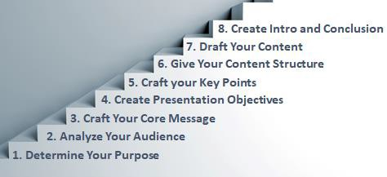

Time to Reflect…
Use the four spaces below to write down:
  - One new thing you learned,
  - Your greatest “ah-ha” moment,
  - One question you had or still have, and
  - One action step you plan to take:

Let’s continue the conversation!
We would love to connect with you!
Hop over to our websites and sign up to receive our monthly newsletters. Connect with us on social media.
Send us an email to share your success stories or to ask questions.
Inquire about digging deeper through one-on-one communication coaching.

Sonja K. Stetzler, MA, RDN, CPC

Website: https://sonjastetzler.com
Facebook: https://www.facebook.com/effectiveconnecting LinkedIn: https://www.linkedin.com/in/sonjastetzler/ Email: sonja@sonjastetzler.com

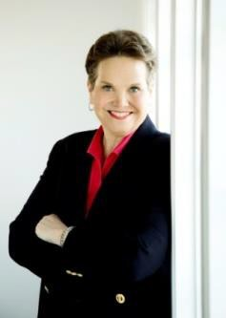
Barbara J. Mayfield, MS, RDN, FAND

Website: www.nutritioncommunicator.com
Facebook: https://www.facebook.com/NutritionCommunicator/ LinkedIn: https://www.linkedin.com/in/barbara-mayfield Instagram: https://www.instagram.com/nutritioncommunicator/ Email: barb@nutritioncommunicator.com

